Question 1:
Matrix A is equal to:
[7, 4, 3],
[12, 7, 5],
[2, 0, 3]
Matrix A⁻¹ (according to Python) is equal to:
[21, -12, -1],
[-26, 15, 1],
[-14, 8, 1]

Verifying the Inverse, I found that A · A⁻¹ is equal to:
[7, 4, 3] [21, -12, -1] [1 0 0]
[12, 7, 5] · [-26, 15, 1] = [0 1 0]
[2, 0, 3] [-14, 8, 1] [0 0 1]
and A⁻¹ · A is equal to:
[21, -12, -1] [7, 4, 3] [1 0 0]
[-26, 15, 1] · [12, 7, 5] = [0 1 0]
[-14, 8, 1] [2, 0, 3] [0 0 1]

Which means A⁻¹ is the inverse of A because both dot products equal I₃.

Question 1 Verification:
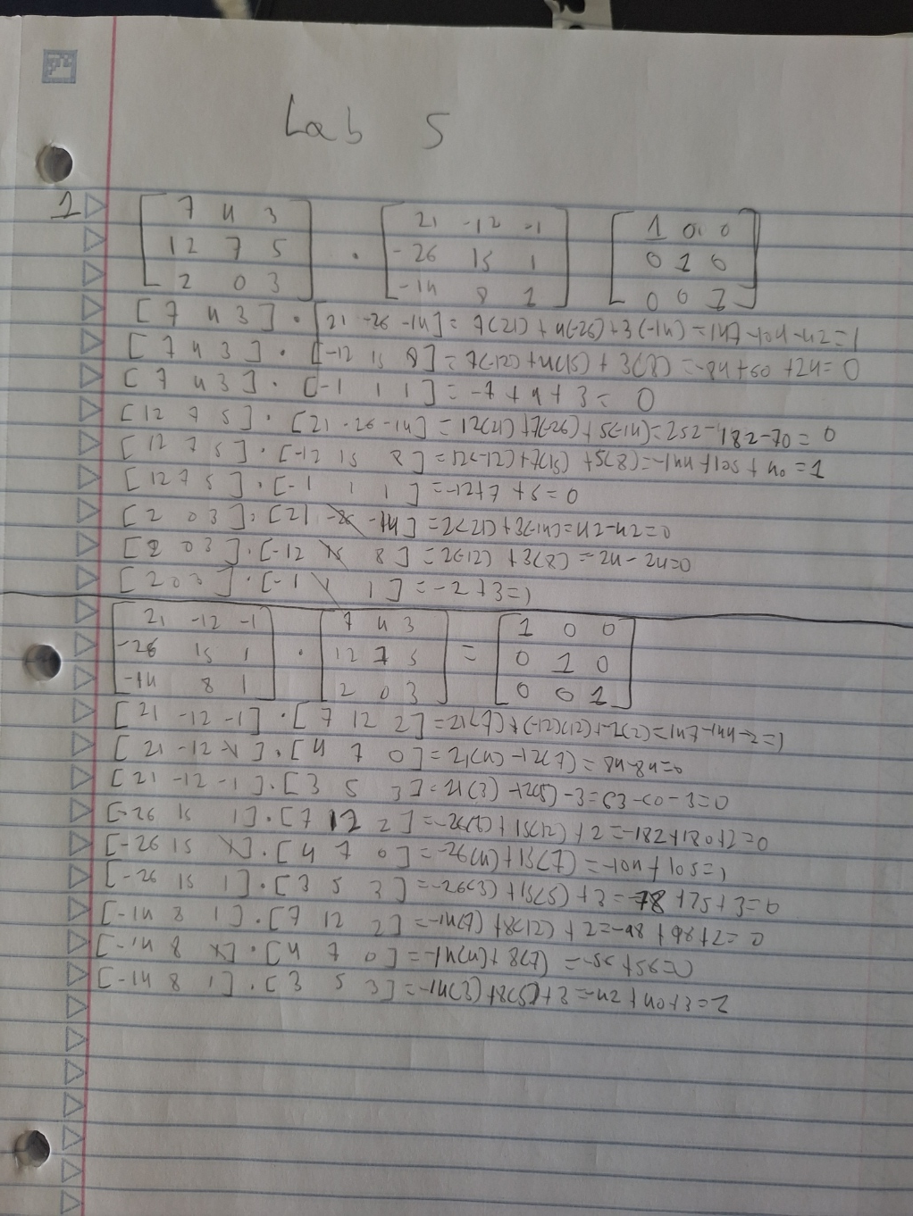
Question 2:
[A | I₃] is equal to:
[1, 3, 5 | 1, 0, 0],
[-2, 5, 1 | 0, 1, 0],
[3, 4, 10 | 0, 0, 1]
[I₃ | B] is equal to:
[1, 0, 2 | 0, -4/23, 5/23],
[0, 1, 1 | 0, 3/23, 2/23],
[0, 0, 0 | 1, -5/23, -11/23]
B is not the inverse of A because the matrix shown as the identity matrix in [I₃ | B] does not equal to I₃.
Question 2:
[A | I₃] is equal to:
[5, 1, 3 | 1, 0, 0],
[-1, 4, 7 | 0, 1, 0],
[6, 9, 11 | 0, 0, 1]
[I₃ | B] is equal to:
[1, 0, 0 | 19/141, -16/141, 5/141],
[0, 1, 0 | -53/141, -37/141, 38/141],
[0, 0, 1 | 11/47, 13/47, -7/47]
B is the inverse of A because the matrix shown as the identity matrix in [I₃ | B] is equal to I₃.

